|  |  |
| --- | --- |
| **DATE** | **07 November 2022** |
| **TEAM ID** | **PNT2022TMID25975** |
| **PROJECT NAME** | **Gas Leakage monitoring & Alerting system for Industries** |
| **MAXIMUM MARKS** | **20 marks** |

|  |  |  |  |  |  |
| --- | --- | --- | --- | --- | --- |
| SPRINT-2 | US-1 | Configure the connection security and create API keys that are used in the Node-RED service for accessing the IBM IoT Platform | 10 | High | Dasa Saranya  Ragavi B  Kristavarapu Ramyasri  Vangala Sowmya |
| SPRINT-2 | US-2 | Create a Node-RED service | 10 | High | Dasa Saranya  Ragavi B  Kristavarapu Ramyasri  Vangala Sowmya |

* Configure the connection security and create API keys that are used in the Node-RED service for accessing the IBM IoT Platform

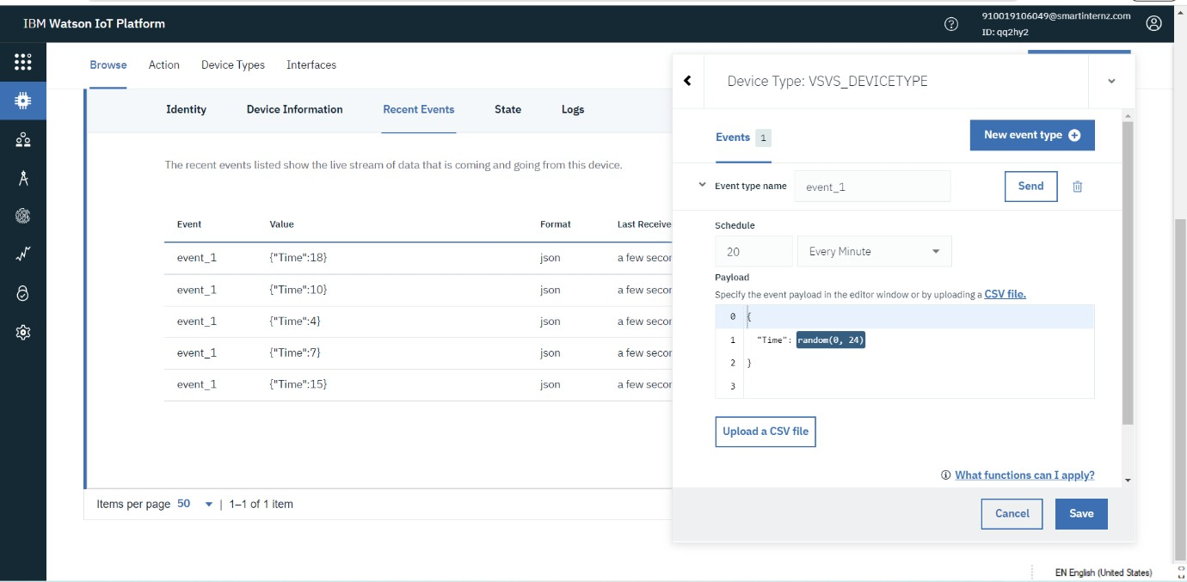

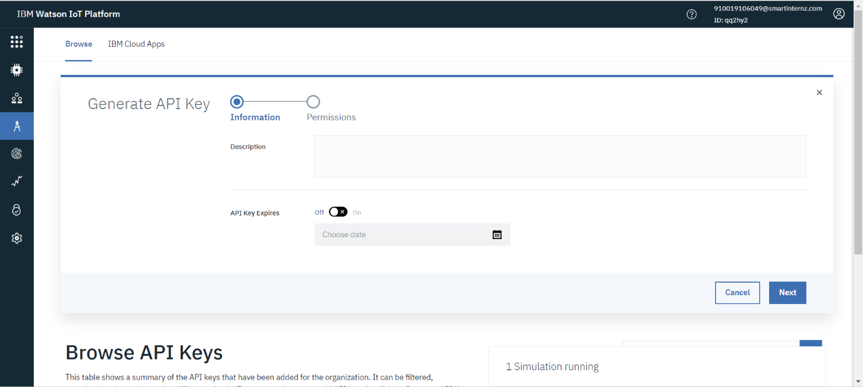

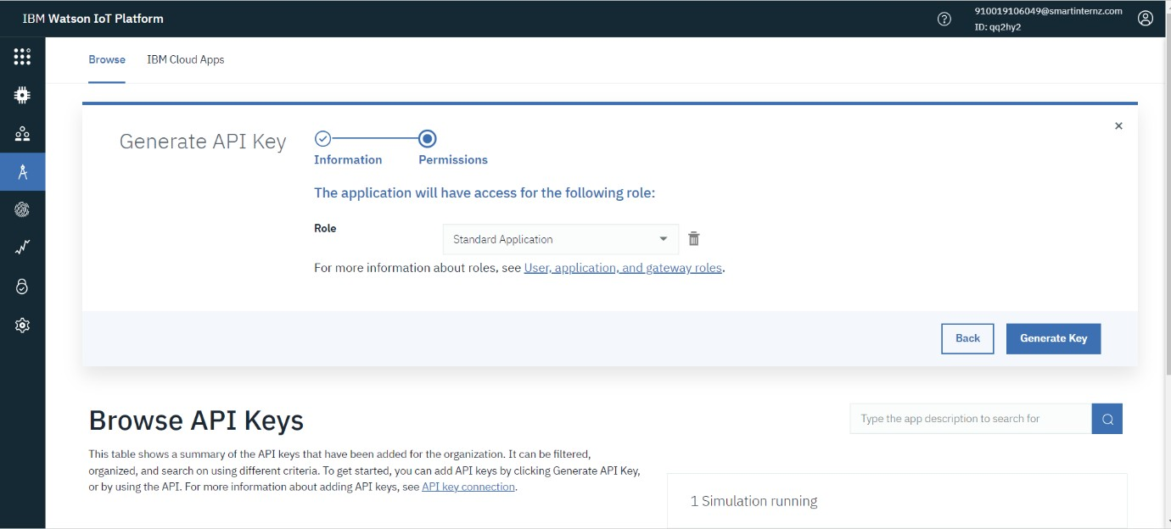

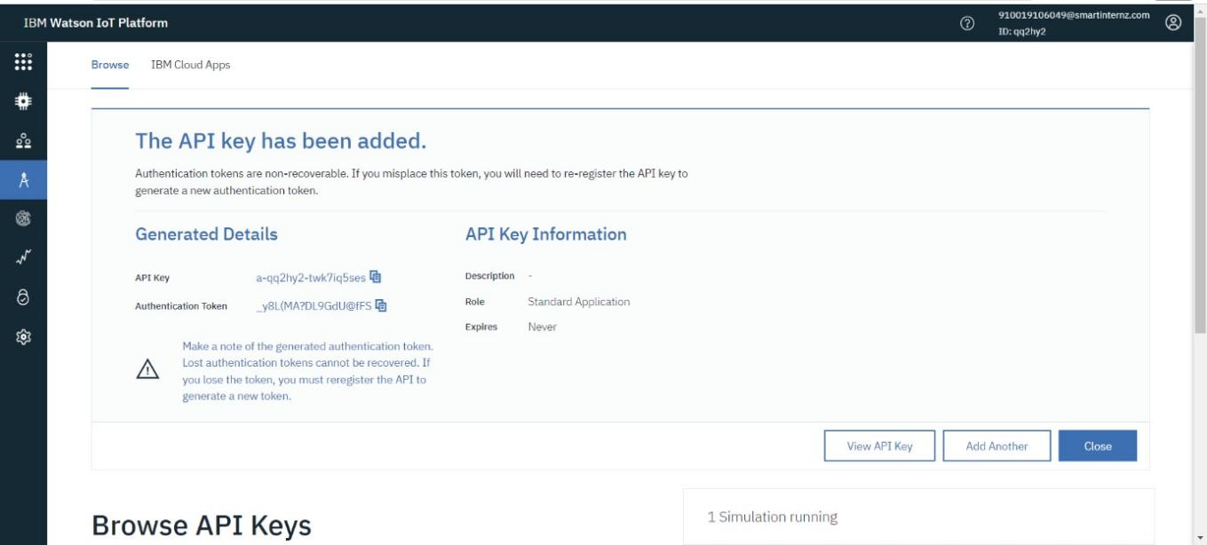

* Create NODE-RED service:

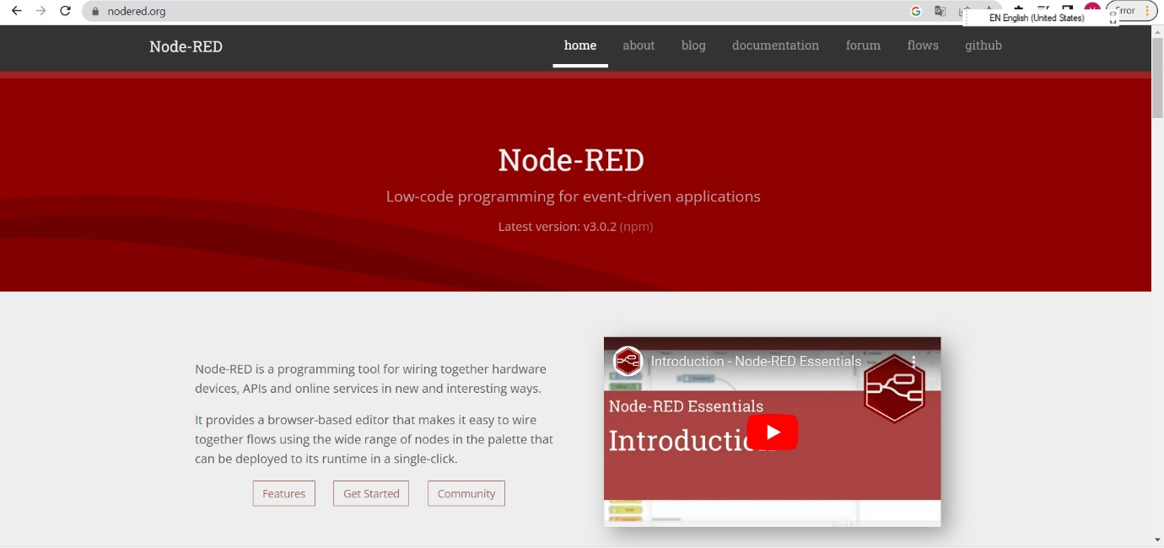



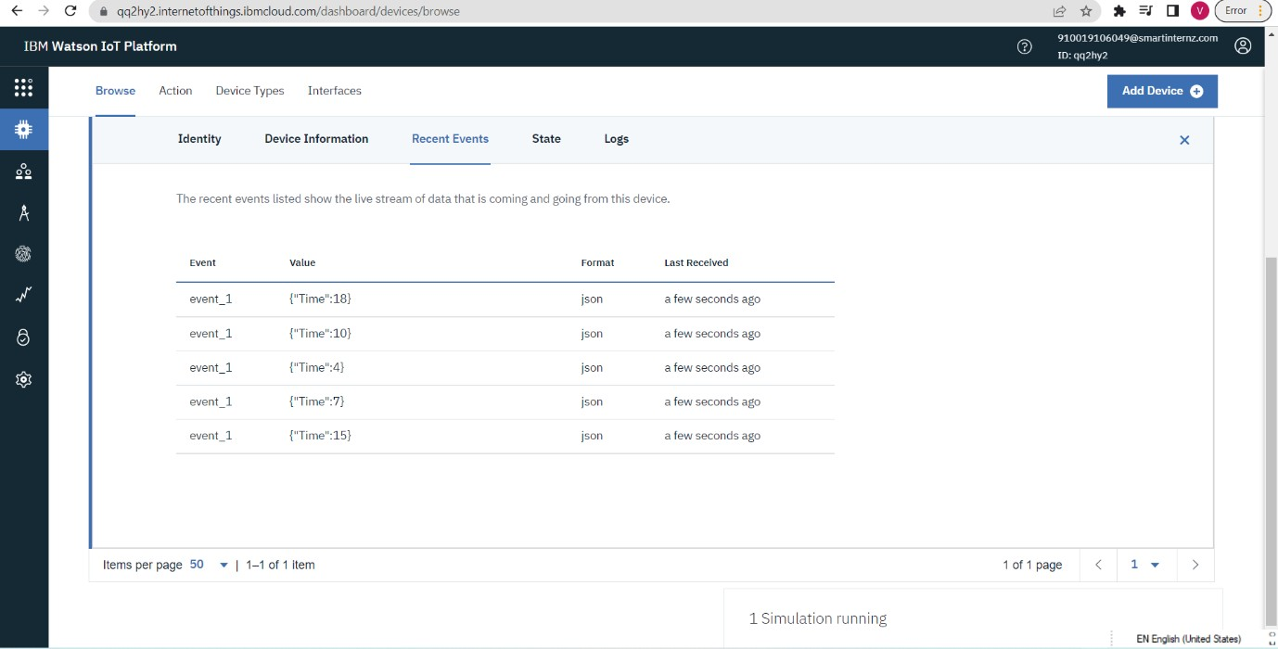

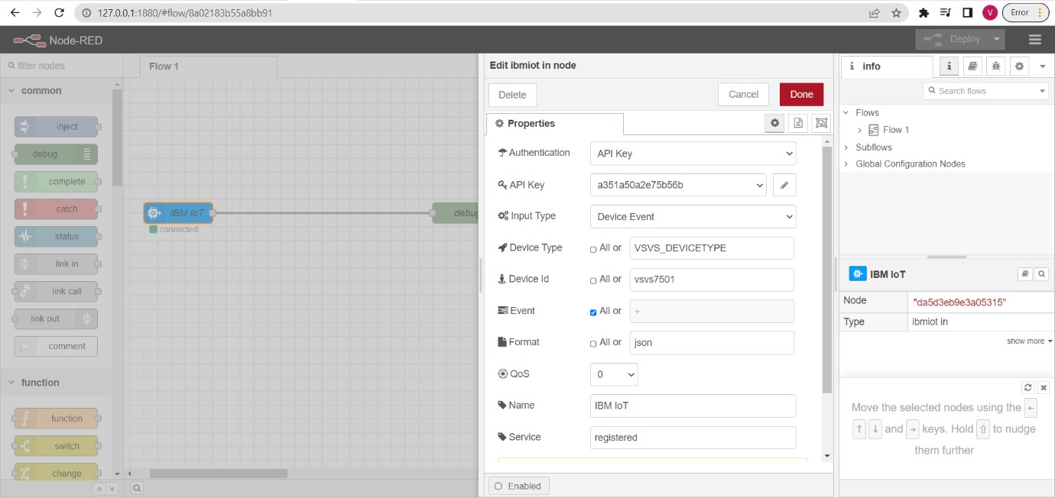

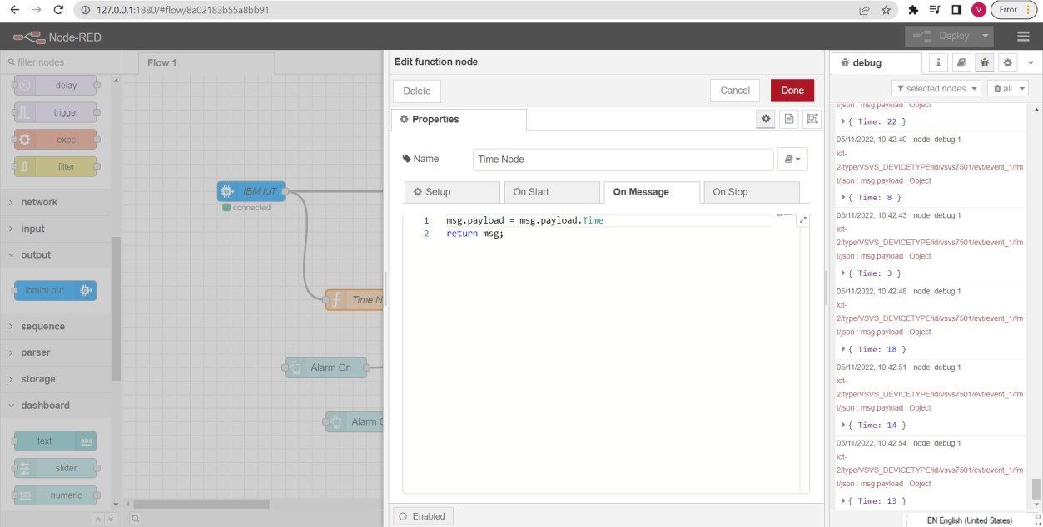

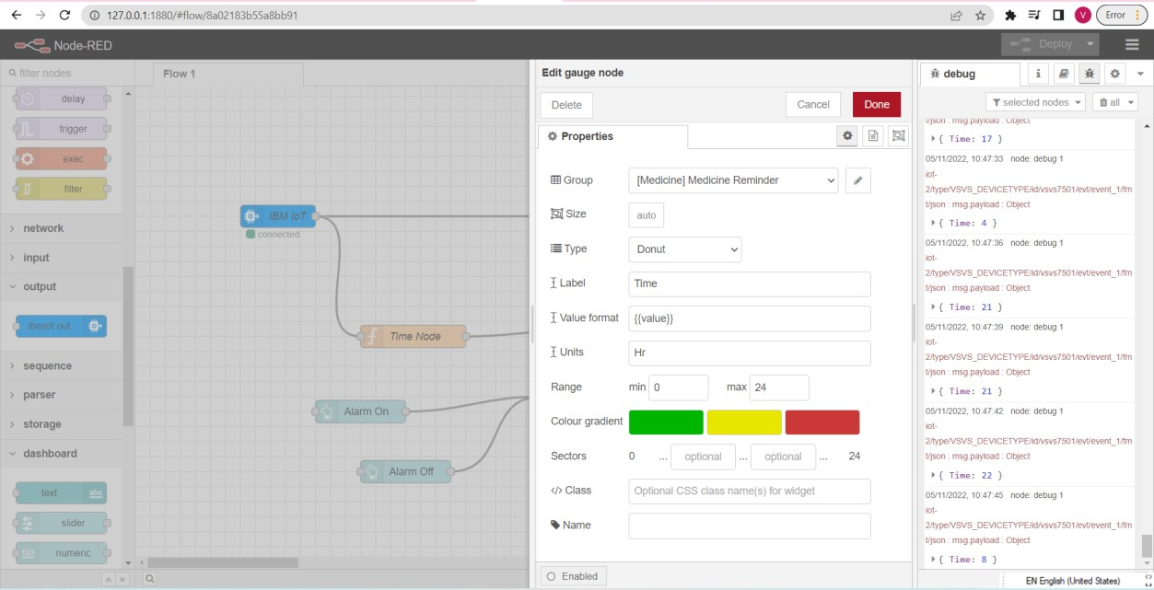

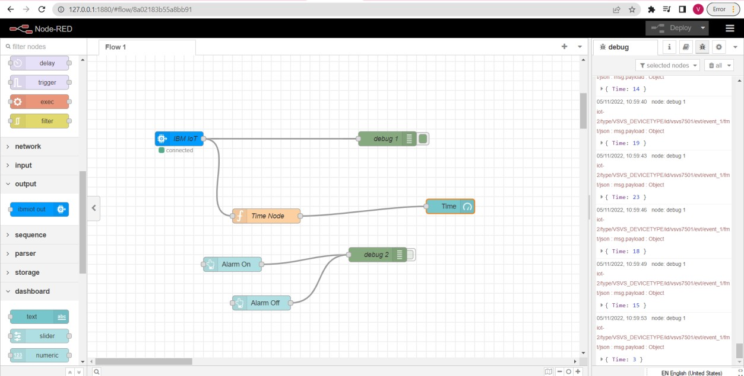

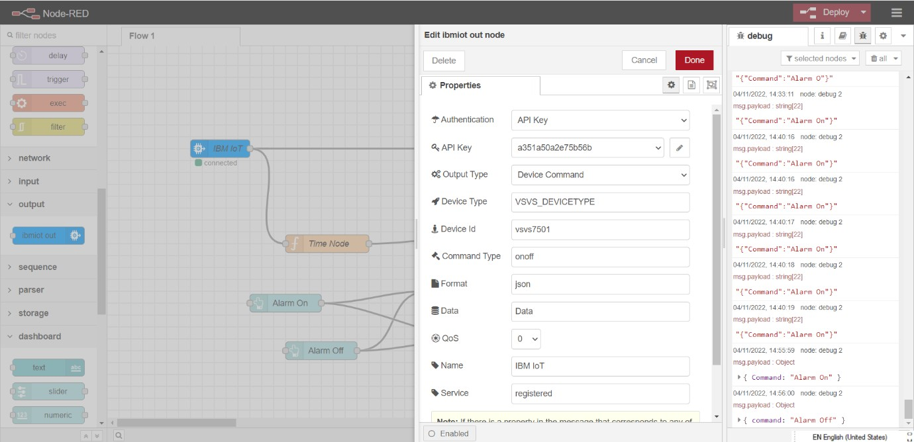

* Properties of Alarm On/Off Node